ENSA Societies & Sports
Disciplinary Policy
- Summary
This document details the policy and processes, for handling complaints and taking disciplinary action relating to the conduct of ENSA’s Sports Clubs, Student Societies and their committees and members.

Effective Date: 01/05/2022
Approved by: Head of Student Communities and Engagement
ENSA contact: Student Activities Coordinator
Last Reviewed/Updated: 10/05/2022
Date due for review: June 2023
Applies to: Sports Club & Society Office Holders/Members
- Reason for Policy
This policy seeks to ensure that there are fair, transparent and appropriate procedures in place for taking disciplinary action relating to Sports Clubs and Student Societies, constituted under ENSA, as well as Office Holders and members.

This policy shall:
- Outline the grounds for taking disciplinary action relating to Sports Clubs, Societies, Office Holders and members.
- Provide a clear procedure for handling and investigating complaints relating to Sports Club or Society conduct
- Provide a clear procedure for disciplinary action.
- Outline the penalties which may result from disciplinary action taken against Sports Clubs, Societies, Office Holders and members.
- Outline the grounds and procedure for appealing any disciplinary action taken.
- Grounds for Disciplinary Action
  - A Society, Sports Club, Office Holder or member, may be subject to disciplinary action for:
    - sexual harassment or inappropriate behaviour of a sexual nature; Including persistent unwanted behaviour when boundaries have been set.
    - discrimination or offensive behaviour based on race, ethnic origin, nationality, skin colour, sex, gender reassignment, sexual orientation, disability, age, religion or belief.
    - Intimidating, threatening, abusive behaviour or physical assault;
    - Intimidating or unwanted behaviour/attention online via social media or messaging platforms
    - contravening Sports Club or Society rules, or breach of the ENSA Sports or ENSA Societies Code of Conduct or policy;
    - holding a Sports Club or Society initiation ceremony – in contradiction of ENSA’s ban on such events;
    - unacceptable conduct bringing ENSA and its Sports Clubs/Societies into disrepute, including via social media platforms
    - theft or misappropriation of Sports Club or Society funds, resources, kit or equipment;
    - financial malpractice, such as misspending the Sports Club or Society funds for unauthorised purposes, or for personal gain, or using a separate bank account to process payment outside of ENSA’s, and members’, scrutiny;
    - failure of Office Holders to ensure participants have paid their membership subscriptions;
    - failure to constitute properly, or, in the case of Sports Clubs, a failure to fulfil a fixture list without good reason;
    - failure to fulfil contractual obligations with third parties;
    - failure to follow good health and safety practice or undertake appropriate checks for undertaking activities;
    - causing damage to, vandalising or stealing, another’s property, especially where this relates to a host organisation, opposing teams and visitors, or an external venue;
    - infringement of competition rules, such as fielding ineligible players;
    - driving, or permitting someone to drive, Members to an event without a valid driving licence for the specific vehicle concerned, the driver or vehicle is not appropriately insured, or the vehicle is not road worthy (evidence of MOT where required).
  - This list is not exhaustive.
- Procedure for handling complaints relating to Sports Club or Society conduct
  - Complaints should be submitted via the online form (available on the ENSA website) to the Student Activities Coordinator, outlining the date, time and nature of the alleged misconduct, and providing evidence and witnesses, where possible.
  - Anonymous complaints cannot be accepted. Complainants must be willing to take part in the disciplinary process and provide testimony and evidence, where required. ENSA understands that some complaints may be of a personal or sensitive nature, and will endeavour to maintain confidentiality where possible, however, this may not be entirely possible as the disciplinary process proceeds.
  - On receipt of a complaint, the Student Activities Coordinator shall act as the Lead Investigator.
    - If a Lead Investigator is witness to the alleged misconduct, or is compromised by a conflict of interest, or too much prior knowledge, the complaint shall be handled by their line manager, who will act as Lead Investigator.
  - The Lead Investigator shall notify the ENSA CEO that a complaint has been received, within 1 working day, providing the date and time of the complaint submission and whether the complaint relates to a Sports Club, Society or both.
  - The Lead Investigator shall notify the defendant person(s), or Sports Club/Society Committee, of the complaint, no later than 5 working days of receipt of the complaint.
    - This notice shall provide the date, time and location of the alleged misconduct, along with a copy of the original complaint, which may be redacted for confidentiality or data protection purposes.
    - This notice should make clear the rights of the defendant person(s) and be accompanied by a copy of this policy.
    - This notice shall also state that the Disciplinary Panel Convener may serve notice of a Sports/Societies Disciplinary Panel Hearing in due course, where required.
  - Where the complainant(s) and/or witnesses are unable or unwilling to take part in a Disciplinary Hearing Panel, the Lead Investigator shall gather evidence and witness statements.
  - The Lead Investigator may be supported by other ENSA staff as necessary.

4.8 Disciplinary Process Flow Chart
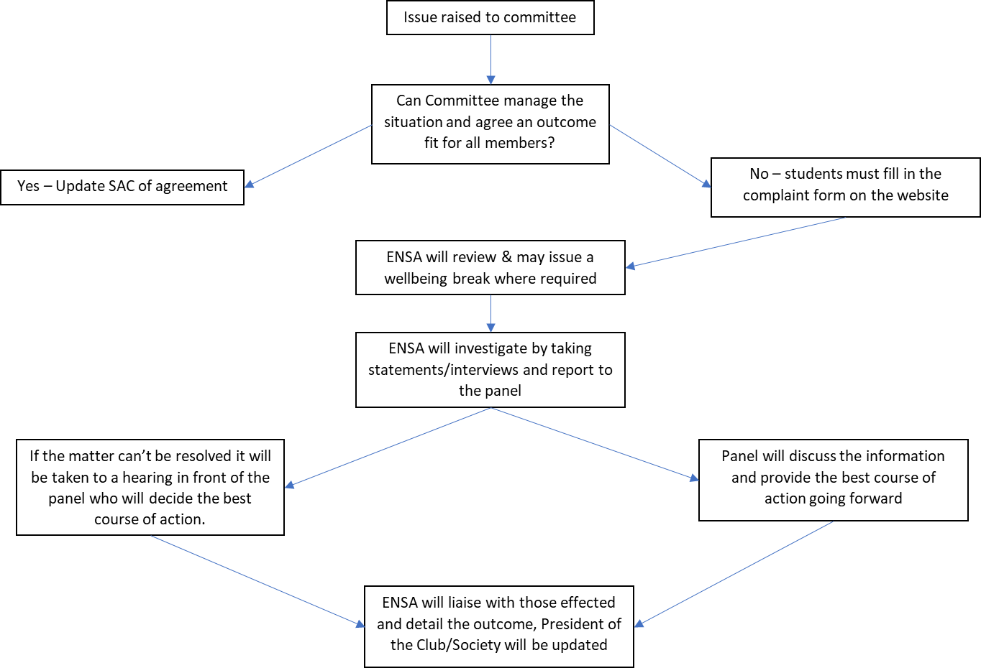
- Safeguarding & Wellbeing Breaks
  - The Lead Investigator, supported by the ENSA CEO, can ask any members involved in a complaint, including complainants, defendant persons and witnesses, to take a ‘wellbeing break’ from Sports Club/Society activities. This is to ensure that appropriate measures are taken to safeguard all members involved.
  - As part of a ‘wellbeing break’, those involved may be advised to limit or cease communication with other members, where possible.
  - A ‘wellbeing break’ in no way implies guilt or fault by any party.
- Sports/Societies Disciplinary Panel
  - Following notification of a complaint, the ENSA CEO shall invite the appropriate Full-Time Elected Officer to convene a Sports/Societies Disciplinary Panel, consisting of the Full-Time Elected Officer as Panel Convener, along with one Student Lay Director, from ENSA’s Board, and a member of ENSA staff, other than a Full-Time Elected Officer.
    - Where a Panel Convener is compromised by a conflict of interest, or too much prior knowledge, an alternative Panel Convener may be appointed, typically another Full-Time Elected Officer.
    - Members of the Disciplinary Panel must not be subject to the action and have no connection with, or prior knowledge of, the circumstances, wherever possible.
  - The Disciplinary Panel Convener may arrange a Disciplinary Panel Hearing to establish the facts of the case, where required.
    - The Panel Convener will contact all appropriate parties, providing five working days’ notice, to notify them of the arrangements.
    - The defendant person(s) shall have the right to be accompanied by a fellow ENSA Member.
    - The Lead Investigator shall be invited to provide the original complaint, as submitted, along with any evidence or witness statements gathered.
    - All parties shall have the right to provide evidence and witnesses, in support of, or against, the complaint(s)/allegation(s), and to ask questions.
    - The Panel shall retire to consider the evidence and come to a decision by majority vote.
- Outcomes and Timescales:
  - The Disciplinary Panel may:
    - uphold the complaint/allegations and impose appropriate penalty/penalties;
    - suspend the disciplinary process for up to one week to seek further evidence;
    - dismiss the complaint due to lack of evidence or witnesses;
    - dismiss the complaint as “no case to answer”; or
    - dismiss the complaint as vexatious or malicious.
  - The outcome of a Disciplinary Panel decision, and any penalties imposed, shall be communicated in writing to the defendant person(s) within one week of the outcome being decided. This notification shall also inform the defendant person(s) that they have one week from the date of this notification to appeal against the outcome, by stating their grounds for appeal and providing evidence for this.
  - The outcome of a Disciplinary Panel decision shall also be communicated, in writing, to the complainant(s), where appropriate. In cases where a complaint is not upheld, this notification shall also inform the complainant that they have one week from the date of this notification to appeal against the outcome, by stating their grounds for appeal and providing evidence for this.
  - A complaint that is deemed vexatious or malicious may also become grounds on which to take disciplinary action against a Member; for example, by imposing a period of suspension or even expulsion from membership.
- Available Penalties
  - When a complaint is upheld, it may be appropriate to issue a penalty, as outlined below. It may also be appropriate to take further action to rectify a grievance, or mitigate any negative effects or consequences, where possible.
  - Available penalties for Office Holders and members:
    - A formal written or personal apology to the complainant.
    - A fine to cover the cost of damage to the complainant.
    - A temporary ban or suspension from the Sports Club or Society; or from playing representative sport for a Sports Club.
    - A ban from holding Sports Club or Society office.
    - Permanent expulsion from the Sports Club or Society; or from ENSA membership.
  - Available penalties for Sports Clubs and Societies:
    - A fine to cover the cost of damage to the complainant.
    - A referral to the ENSA board with a recommendation that the Sports Club or Society be put on special measures, suspended or dissolved.
- Appeals
  - Appeals, in relation to an Office Holders, member or a whole Sports Club or Society, shall be heard by the Chair of the Board, or their appointee, providing they have no connection with, or prior knowledge of, the circumstances.
  - The grounds for appeal against a decision by a Forum Panel relating to a Sports Club, Society or any of their members, may be on the grounds of:
    - procedural irregularity – the Panel failed to follow procedure;
    - the Panel’s action being outside of its remit (ultra vires);
    - the outcome being inconsistent with the outcome or the penalty being too severe, given the offence committed.
  - The appeals stage does not re‐hear the whole case but will restrict itself to reviewing the procedure followed and the evidence on which the original decision was made, and ensuring that it complied with the agreed procedure and that the outcome was reasonable and lawful.
  - An appeal shall normally be heard within 10 working days of receiving it, and a decision on the appeal, in writing, shall normally be issued within a week of the decision on the appeal.
  - The person hearing the appeal may decide to:
    - dismiss the appeal, in which case the original decision, and any penalties, shall stand;
    - review the details of the case, taking account of the appeal; in which case the complaint may then be upheld or dismissed in whole or in part;
    - determine a different penalty or remedy, specifically where the appeal relates to any penalties or remedies issued.

