ENSA Societies & Sports
Transport Policy
Summary
This document details the policy and processes, for booking and the use of various transport by ENSA Societies and Clubs. This is required for any student activities and will align with the various other policies which ENSA’s Sports Clubs, Student Societies and their committees and members should relate to.
Effective Date: 26/05/2022
Approved by: Head of Student Communities and Engagement
ENSA contact: Student Activities Coordinator
Last Reviewed/Updated: 20/05/2022
Date due for review: June 2023
Applies to: Sports Club & Society Office Holders/Members
- Reason for Policy
In order to allow Clubs and Societies to travel safely to events, Office Holders should ensure that their Club or Society understand the policy and procedures set out by ENSA. Following these procedures will ensure clubs or societies book the correct transport, with the correct insurance in place as well as any health and safety requirements.
- Becoming a Driver
2.1 There is no limit on the number of drivers you can register with ENSA however you must declare who is your primary driver. This will be the registered driver on the booking form unless stated otherwise.
2.2 It is strongly advised that you ensure you have two registered drivers per trip especially for trips outside of Edinburgh. This is a requirement where the drivers are participating in high risk or contact sports and activities.
2.3 To drive a car or MPV up to 9 seats you must satisfy the follow criteria:
- Be over 18 years old
- Have been driving for 1 year with a full UK licence
2.4 To drive a 9+ seater vehicle, you must satisfy the enhanced criteria of:
- Be over 21 years old
- Have been driving for 2 years with a full UK licence
2.5 All drivers must add themselves to ENSA’s driver pool, via the new driver form on the ENSA website (www.napierstudents.com) under the transport tool kit.
2.6 Drivers in this pool may be contacted to support other clubs who need additional drivers.
2.7 Approval expires at the end of each academic year. This means existing drivers will need to reapply each year and complete the “ENSA Driver Authorisation form” for that academic year.

- Driver Responsibilities
3.1 All drivers must complete the any documents/form or modules requested by ENSA.
3.2 Any vehicles used for student activities are the sole responsibility of the driver and that vehicle. For vehicles hired from external companies the driver’s responsibilities begin on collection of the vehicle.
3.3 Drivers have the responsibility to ensure all legal requirements are followed including those related to passengers, such as the use of seatbelts etc.
3.4 Drivers of vehicles on hire by ENSA have a responsibility for the following:
- Completion of the Transport Departure Forms (Passenger list, Vehicle inspection, Transport Risk Assessment).
- Payment of fines for road traffic offences obtained whilst driving the vehicle.
- Before any journey drivers should satisfy themselves that their vehicle is in a safe condition in respect of brakes, fuel, oil & water levels, operation of lights, tyre condition and pressure.
- Ensure any questions around the vehicle and breakdown cover policy is asked prior to leaving.
- Drivers must never drink and drive. The effects of alcohol do not wear off after a night's sleep and the Police can still detect level of alcohol the morning after. Similarly, drivers should not begin any journey if under the influence of any drugs.
- Drivers are strongly advised to check the weather and road conditions prior to any journey particularly during the winter months.

- Use of Hire Vehicles
4.1 All vehicles must be hired through ENSA for each club or society.
4.2 Any member who hires a vehicle out with ENSA’s process will be liable to pay the full cost.
4.3 Bookings for transport should be submitted 2 weeks in advance via the transport booking form (via the website) and followed up with an email to the Student Activities Intern/Coordinator.
4.4 Clubs should ensure that any non-members traveling on the vehicle have been approved by ENSA in advance.
4.5 Clubs and Societies can raise funds for a vehicle in order to cover the cost of the hire but vehicles hired through ENSA should never be used as a “taxi service”. Drivers of the vehicle should likewise not be paid or reimbursed from the Club or Society Account.
4.5.1 Any clubs looking to provide a transport service for spectator for events must create a payment system for fares on our booking systems via Native.
4.6 When using a self-drive vehicle, it is the responsibility of each passenger and the club/society office holders to ensure there are no drugs or alcohol consumed on board and that everyone acts in safe and appropriate manner (including no nudity, obscene acts, rude or aggressive behaviour).

- Other types of hire
5.1 ENSA can provide coaches and minibuses with drivers for longer trips or where Clubs or Societies are unable drive vehicles themselves. Please follow the normal transport booking process to do this.
5.2 If Clubs or Societies require Taxi’s or Rideshares for any reason, this should be first approved by ENSA as with any other club expenditure.
5.3 Private vehicles can be used for transportation of passengers but drivers must ensure they have business insurance on their own personal policy. In the event of an accident or incident you are not covered by ENSA’s insurance policy to use your own car and you may also not be covered by your own insurance.
Your own vehicle MUST be logged through the transport booking form, provided you have the relevant insurance confirmation and documents. Only once your request has been approved can you use your own vehicle.
- Costs and Fuel
6.1 All costs of hiring vehicles (including insurance) are taken directly from your club or society account, this is one of the reasons we need to approve all requests to ensure you have enough funds.
6.2 Fuel can be redeemed after travel by using the standard fund requisitions process requiring a dated and itemised receipt within 30 days of purchase.
6.3 Pre-set fuel costs, ENSA has provided an overall milage claim based on journeys from various Universities for fixtures. Fuel costs will be reimbursed at the rate of 25p per mile for trips undertaken by student using their own vehicles.
Aberdeen/RGU | 130 miles
Stirling | 42 miles
St Andrews | 56 miles
Dundee/Abertay | 64 miles
Glasgow/Strathclyde | 47 miles
UWS - Hamilton | 48 miles
UWS – Ayr | 78 miles
UWS – Paisley | 56 miles

6.4 Each supplier has their own rules for refuelling, you should check this with them when picking up a vehicle as failure to follow their policy will incur your club a penalty.

- Accidents
7.1 While we expect all our drivers to driver with care and consideration and ensure all vehicle are parked safely, we understand that sometime accidents can’t be avoided. ENSA will pay the excess for an accident where our driver, club or society is not at fault. However any further claims will be processed through the club account.
7.2 Drivers must fill out the required information about an accident using the Transport Accident form, This is located on the website.

- Penalties
For minor issues such as those listed below will result in 1 penalty point to your club or societies transport booking account. If you reach 3 penalty point in a 12-month period, you risk your transport account being suspended.
Minor Breaches
- Failure to re fuel the vehicle correctly
- Vehicle parking or Bus Lane fines
- Non submission of passenger list
- Failure to report near misses
- Vehicle not returned in satisfactory condition
- Consuming alcohol on a hired vehicle

For issues not outlined above the policy outlined above will be investigate by the ENSA operations team and outcome decided by the investigating staff member and relevant elected officer.
For more information, please see the ENSA disciplinary procedure.
- Transport Booking & Confirmation Process Overview
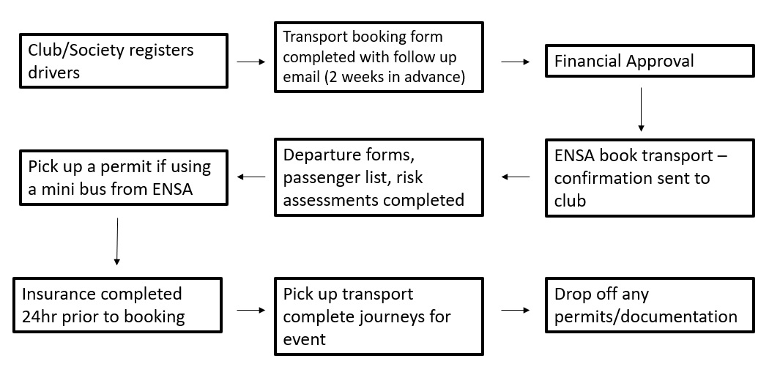
* Please note BUCS Fixtures will be booked in advance where possible, it is still the club’s responsibility to ensure transport has been confirmed. With fixture changes and ad-hoc events clubs must still provide a transport booking in advance.

- Breach of Policy
Failure to follow the policy outlined above will result in disciplinary action being taken, against individuals, full Committees and/or entire Clubs/Societies. (See ENSA’s Sports & Societies Disciplinary Policy).

