
ENSA Societies & Sports
Finance Procedure and Checklist
Summary
This document details the procedure and checklist when dealing with Club/Society Finances.
Effective Date: 13/05/2024
Approved by: Team Lead Student Engagement
ENSA contact: ENSA Finance Officer
Last Reviewed/Updated: 07/07/2025
Date due for review: June 2026
Applies to: Sports Club & Society Office Holders/Members
- Procedure

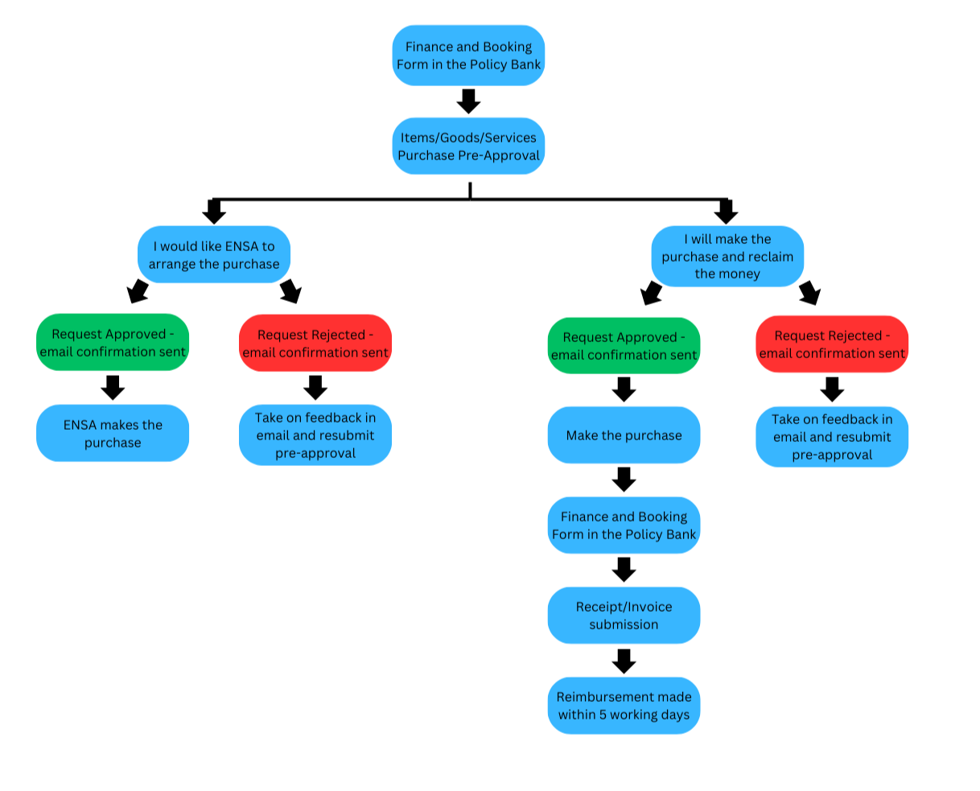

- Checklist
Please use this checklist before, during and after you deal with Club/Society finances.
  - Before
- Consider if this purchase is a want or a need, and the reasoning why it would benefit the club.
- Check your club account on Teams to ensure you have sufficient funds.
- Confirm with committee if you will make the purchase yourself and claim reimbursement, or if you would like ENSA to make the purchase.
- Request pre-approval before spending any money related to the club.

  - During
- Wait for approval confirmation email.
- If your request is rejected – take on feedback on the email and resubmit for pre-approval or contact ENSA.
- Make the purchase and keep any receipts/invoices and bank statements or transactions.
- OR let ENSA make the purchase.

  - After
- Reimbursement will be in your account within 7 working days.
- Collect any deliveries from the ENSA office (B34 Merchiston campus).
- Check the correct amount has been taken from your club account on your Teams channel.

