**ENSA Societies & Sports**

**Transport Procedure and Checklist**

**Summary**

This document details the procedure and checklist when using transport hired by or in relation to ENSA.

**Effective Date:** 13/05/2024

**Approved by:** Team Lead Student Engagement

**ENSA contact:** Student Activities Administrator

**Last Reviewed/Updated:** 07/07/2025

**Date due for review:** June 2026

**Applies to:** Sports Club & Society Office Holders/Members

1. **Procedure**

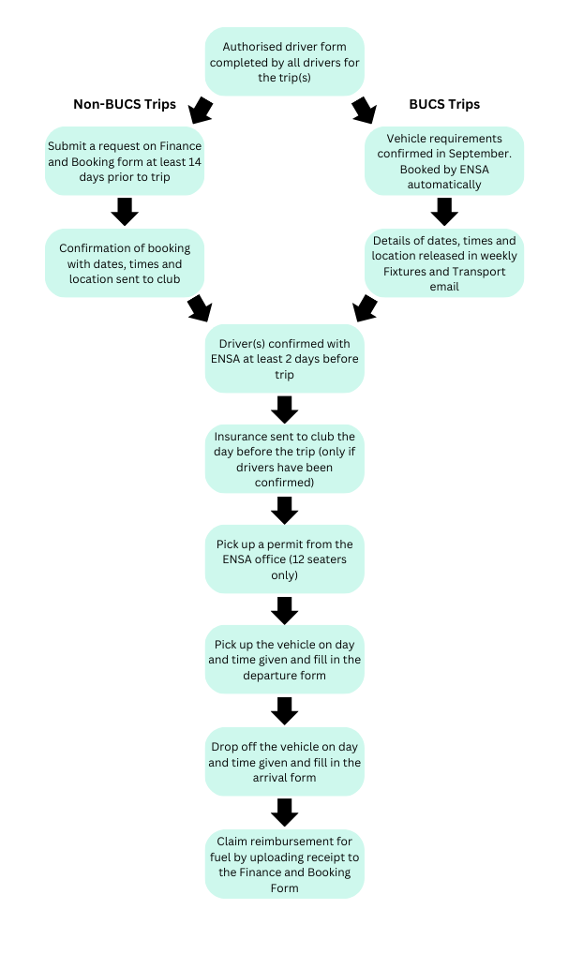

1. **Checklist**

Please use this checklist before, during and after your Club/Society trip.

* 1. **Before**
* Ensure all drivers have completed the ‘Authorised Driver Form’ and received confirmation from ENSA that they are registered to drive.
* Submit transport booking request at least 14 days prior to trip.
* Receive confirmation from ENSA of booking and double check the date, time, vehicle and location details are all correct.
* (For BUCS trips) Confirm required vehicles with ENSA prior to the BUCS season beginning.
* (For BUCS trips) Check weekly Fixtures and Transport Email for date, time, vehicle and location details.
* Confirm driver(s) at least 48 hours before the trip.
* Receive temporary vehicle insurance form ENSA and check the details are correct.
* Collect permit from ENSA office (12 seaters only).
  1. **During**
* Collect vehicle at date, time and location given.
* Sign hire company documents and provide proof of insurance.
* Complete departure form.
* Display permit on dashboard (12 seaters only).
  1. **After**
* Refuel vehicle and keep receipts.
* Return vehicle at the date, time and location given.
* Complete arrival form.
* Request reimbursement of fuel costs via the Finance and Booking Form.